**Med App Draft GUI**

**Doctor’s UX & UI:**

Screen 1: Log in, in this part…the doctor will not be able to see patient. He/She can check the options from the Menu: i) See Patient, ii) Patient Record, iii) Appointments, iv) My AC Info & History, v) Check Notifications, vi) Forum, vii) Settings. The same menu will be available in icons as well.

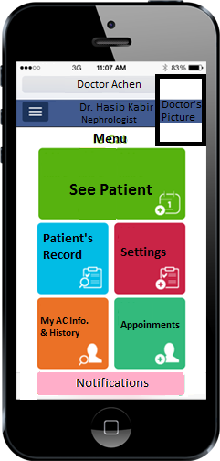

**i) See Patients:** After opening the app the doctor will have to click on “Start Seeing Patients” …….after clicking this the system will count the doctor’s availability and record it. This will also show the respective doctor’s availability to the patients. **Note:** after starting the “See Patient” session, if the doctor is not taking any patient and sitting idle, he will get a notification in every 15 minutes.

The doctor can also stop Patient consultation session by clicking on “Stop Seeing Patients”. This option will not be available during a consultation with a patient.

Message: Your Session started @ 2 pm. Serving as General Practitioner or Dermatologist -----Do we need to have them put a time range like 2pm to 3 pm?

Log in Time: 12:07 PM

Time Elapsed: 1.38. 23

Log in Time: 12:07 PM

Time Elapsed: 1.38. 23

576

Number of General Patients Waiting:

576

Number of General Patients Waiting:

12

Number of Spcl. Need Patients Waiting:

Number of Spcl. Need Patients Waiting:

0

Notify When SNPs Waiting

Notify When SNPs Waiting

Click

Start Consultation as SP

Start Consultation as GP

**Stop Patient Consultation**

**Stop Patient Consultation**

GP : General Practitioner, SP: Specialized Practitioner

**Note:** We are not allowing the SP to consult as GP if SNP (Special Need Patient) is waiting. In the left Picture there is no SNP waiting so the doctor can see patient as a GP. In the right picture, there are 12 SNPs are waiting that’s why General patient and “Notify for SNP” turned grey. This button will not work and the doctor will have to see patient as an SP. There must be more GPs than SPs. A GP will not get the SNP notification bar on his/her device. Therefore, no need to have a “Notify for SNP” tab.

- Move on to the next screen:

00:06:49

Patient

Profile

Picture

Name:

Age:

Sex:

ID:

Member Since:

Patient’s Profile

This will lead to the next page which is Consultation Dashboard

To resolve any technical issues

Start

Prescribing

Doctor can call his Assistant if any

Call

Operator

Call

Assistant

- Move On….

Regular Clock

Elapsed Time to keep track

11:23PM

00:06:49

Consultation Dashboard

End Call

Call Operator

Start Video Chat

Benchmark Viber Video Feature

Diagnosis

Chief Complain

(Content Pending)

Rx

Pre-Existing Illness

Advice

(Content Pending)

Investigation

(Content Pending)

Untouched tabs will be Grey

Should we allow the doctor to Edit this?

Refer Patient

Medical History

Will directly take picture and upload

**Upload**

**Prescription**

**Generate**

**Prescription**

(Content Pending) **: These will be fetched from the data base and will work like Google Search option. This will be provided by our Doctors’ Team.

11:23PM

00:06:49

Chief Complains

c

1. Stomach Ache

Delete an Existing Row

2. Sore Throat

Content will be provided for auto search by letters and words like Google search

3. Nausea

Add More Rows. (Not more than 7)

Save & Go Back to Consultation Dashboard

**Done**

Pre-Existing Illness

11:23PM

00:06:49

Light up with color if selected

CAD

HTN

CLD

Stay Grey if not selected

Br. Asthma

COPD

CKD

Drop down box to insert drug name. Linked to the Drug list for auto search.

DM

Enter Drug Name

Other

Enter Other Illness

1. Angilok

2. Triopid

1. *Write Here*

Done

Done

None

**Done**

11:23PM

00:06:49

Investigations

c

There will be additional Drop-Down Box to mention the tests’ name

1. Blood Test

Select Test Names

CBC

HGB

2. X-Ray

CRP

There will be a list of tests

Content will be provided for auto search by letters and words like Google search

3. MRI

Done

**Done**

For **Medical History** Please see Attached Template.

Medical History can be inserted or edited by doctor, by patient, by operator or by patient’s attendant or

Friends & Family member (Only applicable for family Account)

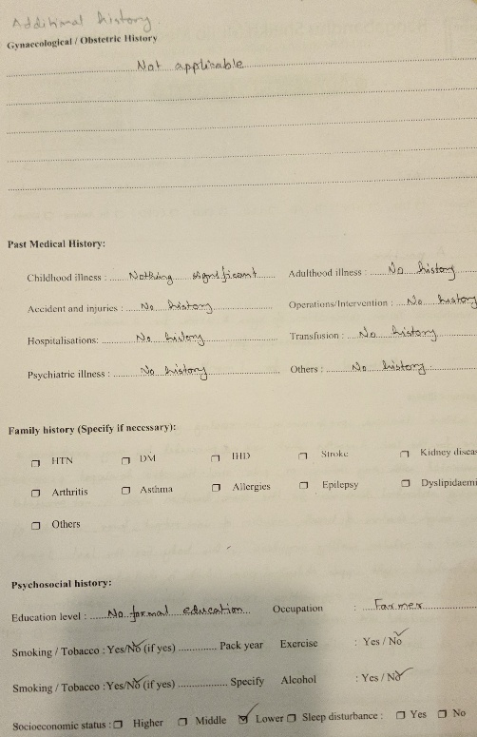

**Done**

1. Viral Infection

11:23PM

Diagnosis

00:09:41

11:23PM

00:09:41

**Rx**

**1**

Trade Name: Zimax Tab 500 mg

Count

This will work like google search

Generic Name: Azithromycin

This will contain **Formulation** & **Strength**. Follow **DIMS App** for this

The Doctor will put either the Trade Name of the Generic Name. System will auto fill the other one.

Dose:

**Done**

**1.5**

**0**

**1.5**

This will be a drop down menu. Ex: 0.5,1,1.5 etc. up to 6

Before Sleep

After Meal

Before Meal

Direction:

Continue

Days

25

Duration:

**Add to List**

List of Prescribed Medicines

1. Napa

2. Viodine

3. Nebicard

4. Omidon

**Done**

11:23PM

00:06:49

Patient Advice

c

1. No Smoking

2. Drink 3 Ltr. water a day

Content will be provided for auto search by letters and words like Google search

3. Don’t Eat Red Meat

**Done**

**Done**

11:23PM

Refer Patient

00:09:41

Search by Doctor ID or Name

DR145222

**ii) Patient Record:**

This will go to the “Menu” Page

Home

Patient Record

Search by Patient ID

Search by Patient Name & DOB

Name:

Search

DOB: DD/MM/YYYY

Home

Patient Record

Search Result of Patient

3

Number of Patient Found

Select the desired Name

Select

1. Muhibul Alam

Select

Select

3. Mahibul Islam

2. Mohibul Islam

Will go to the previous page

Refresh

Patient Record

Home

Name: Mohibul Islam

Age: _ _/ _ _/ _ _ _ _

Sex: Male

ID: DF8364346

Member Since:

Patient

Profile

Picture

Pre-Existing Illness

Treatment Record with Doctor Achen

These will be used in other places as well

We work on this Later

Medical History

Lab Investigation Reports

Home

Previous Page

Patient Record

Treatment Record with Doctor Achen

Patient Name: Patient Id:

Please Enter a Date Range:

To:_ _/_ _/_ _ _ _

From:_ _/_ _/_ _ _ _

Refresh

Search

Ascending or Descending Order by Date

View

View

View

Mizanur Rahman

2.3.18

Time

Order:

Doctor’s Name

Date

Search Result:

Select

10:07PM

Note: A doctor can change treatment record only if he saw the patient before. Which means he can only change his own consultation record. However, the doctor may have to give an explanation about the newly made changes. After making the changes, the patient will be notified by a message from the App.

Patient Name, Sex, Age, ID, Date

This will be a dropdown Menu:

i) Export as PDF

ii) Export as JPG

iii) Share

Note: “Share” will display & give Email and OTT Options

Edit

Home

Prescription

This will take the Doctor to the Consultation Dashbaord

Doctor’s Name: **<Also our App name, logo & Ph#>**

Pre-Existing Illness

Rx

Advice

This is an electronically generated prescription that doesn’t require any stamp or signature

Digital Signature Note

Investigation

Chief Complain

Diagnosis

ID:

Age:

Sex:

Date:

Patient’s Name:

**Note:** Only the prescribing doctor will be able to Edit this. Other doctors or patients will not see this.

Could we have a water mark of our logo in the middle of the Prescription?

**Note:** User must be able to Zoom the prescription

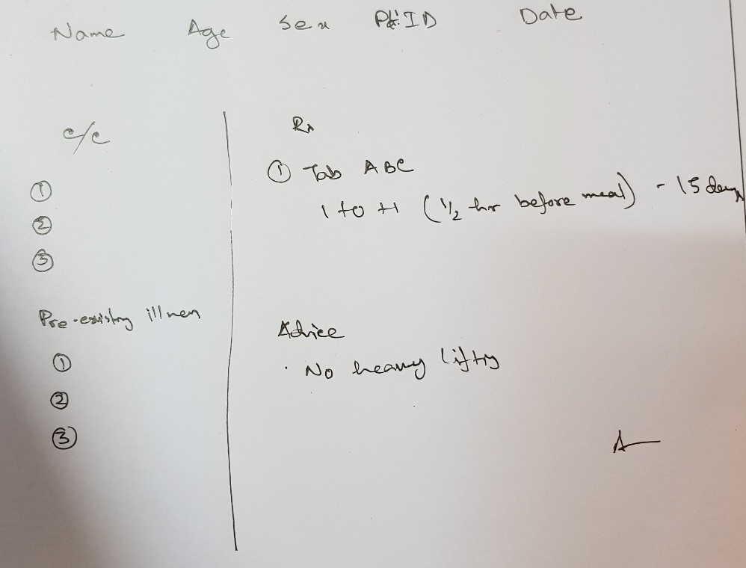

The Above Picture is a Sample Prescription Content

iii) Appointment will be known as **Schedule**: The Following page will be displayed after clicking on “Appointments” or “Schedule”

Schedule

Home

Work Schedule

Appointment Requests

Scheduled Appointments

Work Schedule

Previous Page

Home

Selected

Should be able to Edit

List View

Calendar View

4

Number of Schedules Found:

System will ask for final confirmation.

Add

<Put Date>

<Put Time Range>

Delete

11:00AM-11:45AM

12/3/2018

In this case the patient already booked a time within this schedule. The system will take the doctor to the next page for further action.

Delete

1:00PM-4:30PM

2/5/2018

There will be different Color code for old or First-time patient

Home

Previous Page

Scheduled Appointments

**Note:** Patient’s request will be automatically finalized if fall within the doctors pre-posted schedule.

Edit

Mokim Uddin

DG125486

2.5.18

2.30 pm

Time

Patient ID

Date

Patient Name

**Reason for Cancellation:** The doctor will have to write a reason. This will be notified to the Admin and Coordinator. Policy will Apply & Patient will be notified.

3.5.2018

Enter a New Date:

9:45PM

Enter a New Time:

Cancel Appointment

Done

Previous Page

Appointment Requests

Home

Time

Date

Patient ID

Patient Name

Counter Request

Cancel

3.30 pm

4.5.18

DF254886

Shirajul Islam

Accept

10:45PM

Enter a New Time:

6.5.2018

Enter a New Date:

Go Back

Done

**My AC Info & History:**

Consist of: i) What Payment has been made so far, ii) What is the current Ac Receivable, iii) Payment Transaction & Bank information Change Options.

My AC Info & History

Home

This will contain: i) Option for a Date Range to find info, ii) will include Patient Name, ID, etc, iii) Treatment Date & Time, iv) View details to access the prescription.

Treatment History

AC Balance

My Profile

This will contain all personal information of the doctor. Any changes made in the profile will be subject to verification by the App Admin.